* Limits 1
* Continuity 2
* The Derivative 3
* Basic Differentiation Formulas 4
* Applications of the Derivative 5
* The Integral 6
* Basic integration Formulas 7
* Applications of Integration 8
* Differential Equations 9

*Table of Contents*

Limits

# What is a limit?

The height that a function *intends* to reach, even if the function never reaches the height

Proper Notation: *“The limit of f(x) as x approaches C is L.”*

The limit of

$\lim_{x→C}{f(x)}=L$

As x approaches C

The Function

Is equal to L

## Example:

The limit of $x^{2}-x+7$ as x approaches 2

$\lim_{x→2}{x^{2}-x+7}=9$

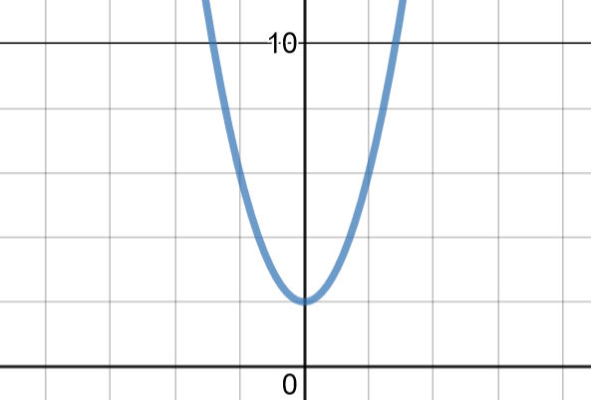

## Graphical Example:

The Limit of the function as x approaches 0

is equal to 2

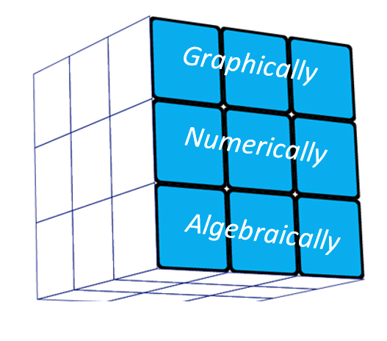

# Methods of Evaluation

There are three methods of evaluating limits: graphically,

numerically, and algebraically.

In this section we will find $\lim_{x→1}{\frac{x^{2}+4x-5}{x-1}}$

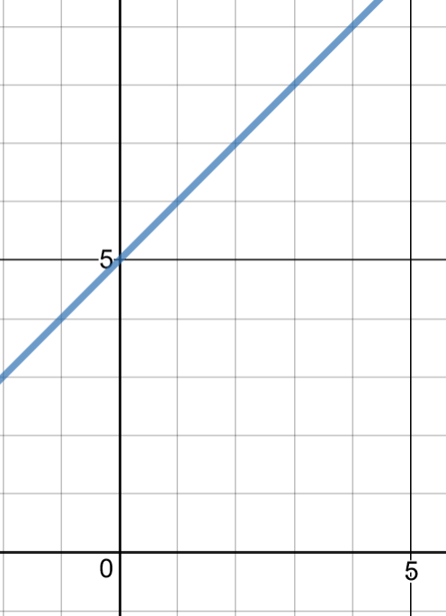using all three of these methods]

## Graphically:

$f\left(x\right)= \frac{x^{2}+4x-5}{ x-1}$

Take the graph shown here of function

f. f(1) does not exist, but based on the

behavior of the graph we can predict the

function intended to reach a height of 6, so

$\lim_{x→1}{\frac{x^{2}+4x-5}{x-1}}$

Tip for me: Remember the 3 techniques as GAN (A Rubik’s Cube Company) - Graphically, Algebraically, Numerically



## Numerically:

If a graph of the function is not available, or you have difficulty with the algebraic approach, try the numeric method. The Numeric method will ***ALWAYS*** work.

Again we will use our function $f\left(x\right)=\frac{x^{2}+4x-5}{x-1}$

To evaluate numerically, create a chart including both sides of the target x value, with values becoming increasingly closer to the target, x = 1 in this case.

|  |  |
| --- | --- |
| x | f(x) |
| 0 |  |
| 0.9 |  |
| 0.99 |  |
| .999 |  |
| 1 |  |
| 1.001 |  |
| 1.01 |  |
| 1.1 |  |
| 2 |  |

Next, plug these values into the function, and compare the values each side seems to approach

|  |  |
| --- | --- |
| x | f(x) |
| 0 | 5 |
| 0.9 | 5.9 |
| 0.99 | 5.99 |
| .999 | 5.999 |
| 1 | DNE |
| 1.001 | 6.001 |
| 1.01 | 6.01 |
| 1.1 | 6.1 |
| 2 | 7 |

In this case, ***BOTH*** sides approach f(x) = 6 as x approaches 1, so

$$\lim_{x→1}{\frac{x^{2}+4x-5}{x-1}}=6$$

## Algebraically:

(also referred to as Analytically)

When solving algebraically there are 3 steps or techniques to follow.

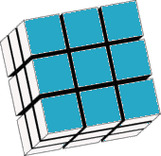**Step #1:** Try direct substitution

Direct Substitution

**Step #2:** Factor/simplify until direct substitution is possible

**Step #3:** Rationalize the numerator

Direct Substitution:

If you’re lucky, substituting c into x will lead to the correct value

For example, to solve $\lim_{x→2}{(x^{2}-6x+1)}$ you can plug 2 into *f*(x)

$2^{2}-6\left(2\right)+1= -7$

If direct substitution leads to indeterminate form ($\frac{0}{0}$) or leads to a zero in the denominator, direct substitution does not work immediately

Divide Out/ Rationalize

Factoring and Dividing Out:

The goal of this step is to simplify until direct substitution is possible.

$\lim_{x→-2}{(\frac{x+2}{x^{2}-4})}$

Direct substitution leads to indeterminate form here

$\frac{-2+2}{{\left(-2\right)}^{2}-4}=\frac{0}{0}$

By dividing out the x + 2, direct substitution can then occur

$\lim_{x→-2}\left(\frac{1}{x-2}\right)=\frac{1}{-2-2}=-\frac{1}{4}$

Be aware that dividing out does not lead to the same function, but a function that will have the same limit as it is identical for all but one point

Squeeze Theorem

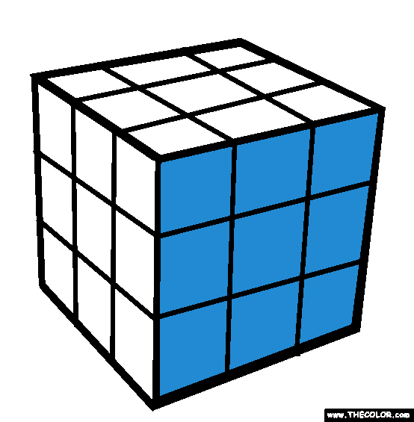

## When do limits fail to exist?

Once again, there are *three* main reasons that limits may fail to exist.

Reason 1: Different left and right hand behavior

The function approaches different heights as it approaches the value from each side

Example: $f\left(x\right)= \left\{\begin{matrix}-2, x≤0 \\ 1, x>0\end{matrix}\right\}$ $\lim_{x→0}{\frac{1}{x^{2}}}$

|  |  |
| --- | --- |
| x | f(x) |
| -1 | -2 |
| -0.1 | -2 |
| -0.01 | -2 |
| 0 | -2 |
| 0.01 | 1 |
| 0.1 | 1 |
| 1 | 1 |

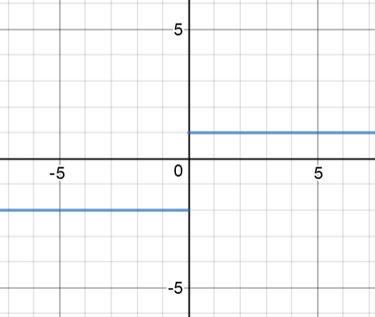

The function intends to reach different heights at 0 approaching from each side

Reason 2: Oscillating behavior

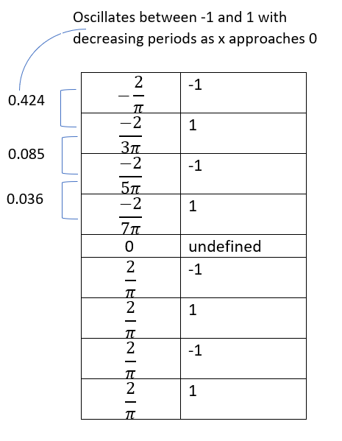The function oscillates between two fixed values as it approaches a value. As the function approaches the value, the period of oscillation becomes infinitely smaller, so it cannot be determined what value the function intends to reach

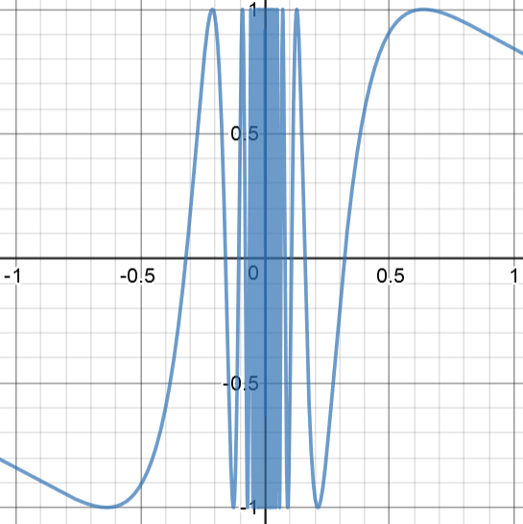

Reason 3: Unbounded Behavior

The function increases without bound as x approaches the value

Example: $\lim_{x→0}{\frac{1}{x^{2}}}$

f approaches infinity as x approaches 0

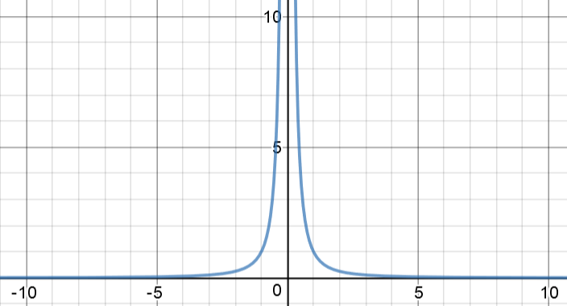

|  |  |
| --- | --- |
| x | f(x) |
| -1 | 1 |
| -0.1 | 100 |
| -0.01 | 10,000 |
| 0 | Undefined |
| 0.01 | 10,000 |
| 0.1 | 100 |
| 1 | 1 |

## What is a one-sided limit?

Notation:

$\lim_{x→c^{+}}{f(x)}$ Definition: The height that the function f intends to reach as it approaches c from the *right*

$\lim_{x→c^{-}}{f(x)}$ Definition: The height that the function f intends to reach as it approaches c from the *left*

The value of both of these limits may be different depending on the function’s behavior there. It is also possible for one to exist without the other

For example, take the piecewise function $f\left(x\right)= \left\{\begin{matrix}x+2, x<0 \\ x^2, x>0\end{matrix}\right\}$

From the right, the function intends to reach a height of 0 as it approaches x = 0. From the left, the function intends to reach a height of 2 as it approaches x = 0

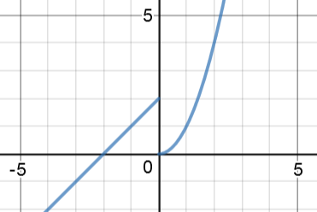 *f*

|  |  |
| --- | --- |
| x | f(x) |
| -1 | 1 |
| -0.1 | 1.9 |
| -0.01 | 1.99 |
| 0 | Undefined |
| 0.01 | 0.0001 |
| 0.1 | 0.01 |
| 1 | 1 |

$\lim_{x→0^{-}}{f(x)}=0$ $\lim_{x→0^{-}}{f\left(x\right)=2}$

# What is a general limit?

In order for a general limit to exist, $\lim_{x→c^{+}}{f\left(x\right)}=\lim_{x→c^{-}}{f\left(x\right)=L}$. In this case, $\lim_{x→c}{f\left(x\right)}= L$

Take the piecewise function $f\left(x\right)= \left\{\begin{matrix}-x, x<0 \\ x^3, x>0\end{matrix}\right\}$

|  |  |
| --- | --- |
| x | f(x) |
| -1 | 1 |
| -0.1 | 0.1 |
| -0.01 | 0.01 |
| 0 | Undefined |
| 0.01 | 0.000001 |
| 0.1 | 0.001 |
| 1 | 1 |

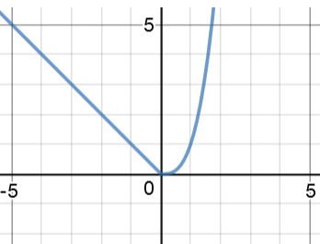

In the example above,

$\lim_{x→0^{-}}{f(x)}=0$ and $\lim_{x→0^{+}}{f\left(x\right)=0}$

Since both one-sided limits are equal,

$\lim_{x→0^{+}}{f\left(x\right)}=\lim_{x→0^{-}}{f\left(x\right)=0}$, so $\lim_{x→c}{f\left(x\right)}= 0$.

When the one-sided limits do not agree, the general limit doesn’t exist.

$$f\left(x\right)= \left\{\begin{matrix}-x, x<0 \\ 3x+2, x>0\end{matrix}\right\}$$

|  |  |
| --- | --- |
| x | f(x) |
| -1 | 1 |
| -0.1 | 0.1 |
| -0.01 | 0.01 |
| 0 | Undefined |
| 0.01 | 2.03 |
| 0.1 | 2.3 |
| 1 | 3 |

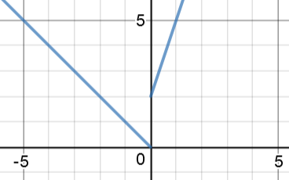

*f*

$\lim_{x→0^{-}}{f(x)}=0$ and $\lim_{x→0^{+}}{f\left(x\right)=2}$

$\lim_{x→0^{+}}{f\left(x\right)}≠\lim_{x→0^{-}}{f\left(x\right)}$, so $\lim_{x→c}{f\left(x\right)}= DNE$

# Limits at infinity vs Infinite limits

Starting with infinite limits.

If you recall, one of the three reasons a limit may fail to exist is unbounded behavior. Infinite limits help us further specify the functions behavior when this happens.

Notation Meaning

$\lim_{x→c}{f\left(x\right)}= ±∞$ The value of *f*(x) increases without bound as x approaches c from either side.

You can use infinite limits with one-sided limits as well.

$$f\left(x\right)=\frac{1}{x}$$

|  |  |
| --- | --- |
| x | f(x) |
| -1 | -1 |
| -0.1 | -10 |
| -0.01 | -100 |
| 0 | Undefined |
| 0.01 | 100 |
| 0.1 | 10 |
| 1 | 1 |

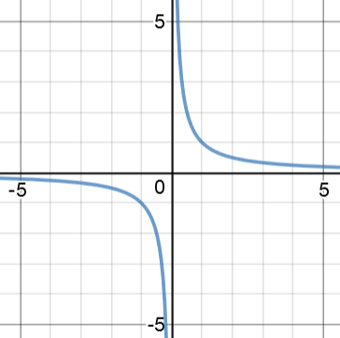

|  |  |
| --- | --- |
| x | f(x) |
| -1 | -1 |
| -0.1 | -10 |
| -0.01 | -100 |
| 0 | Undefined |
| 0.01 | -100 |
| 0.1 | -10 |
| 1 | -1 |

Previously we would say that $\lim_{x→0^{-}}{f(x)}=DNE$ and $\lim_{x→0^{+}}{f\left(x\right)=DNE}$ due to unbounded behavior. Now, using infinite limits we can notice that $\lim_{x→0^{-}}{f(x)}=-∞$ and $\lim_{x→0^{+}}{f\left(x\right)=∞}$, but $\lim_{x→0}{f(x)}=DNE$

$$f\left(x\right)=\frac{-1}{x^{2}}$$

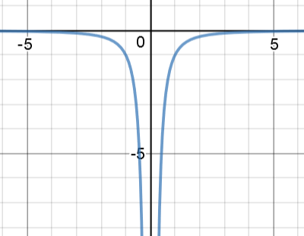

Previously we would say that $\lim_{x→0^{-}}{f(x)}=DNE$ and $\lim_{x→0^{+}}{f\left(x\right)=DNE}$ due to unbounded behavior. Now, using infinite limits we can notice that $\lim_{x→0^{-}}{f(x)}=-∞$ and $\lim_{x→0^{+}}{f\left(x\right)=-∞}$, and since the one-sided limits are equal, $\lim_{x→0}{f\left(x\right)=-∞}$

Vertical asymptotes also occur when $\lim_{x→c^{±}}{f(x)}=±∞$